(\*1) – add reason for choosing the BG2, on others.

Add nicely example for run:

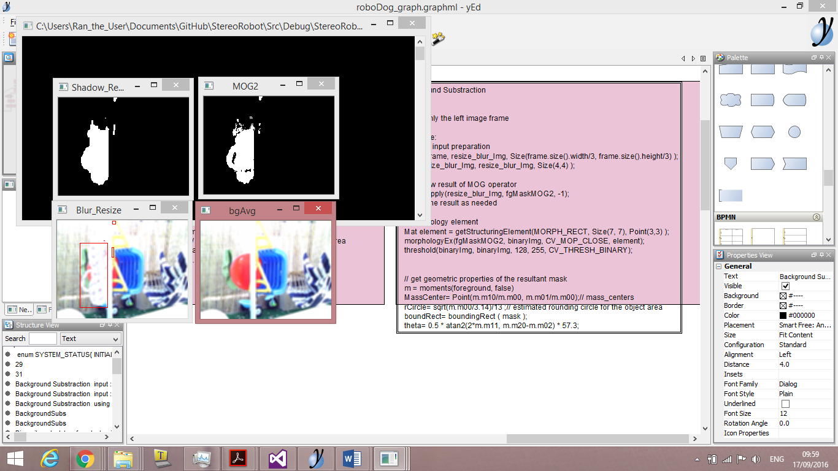

4 3

1 2

After start , moving rope in front of camera , shows that background is not affected , but foreground is quickly shown. #4 is after thresholding

Bg subs for depth:

<https://www.youtube.com/watch?v=VBisVCnXxjI>

ref to bgsubs opencv :

<http://docs.opencv.org/trunk/d1/dc5/tutorial_background_subtraction.html>